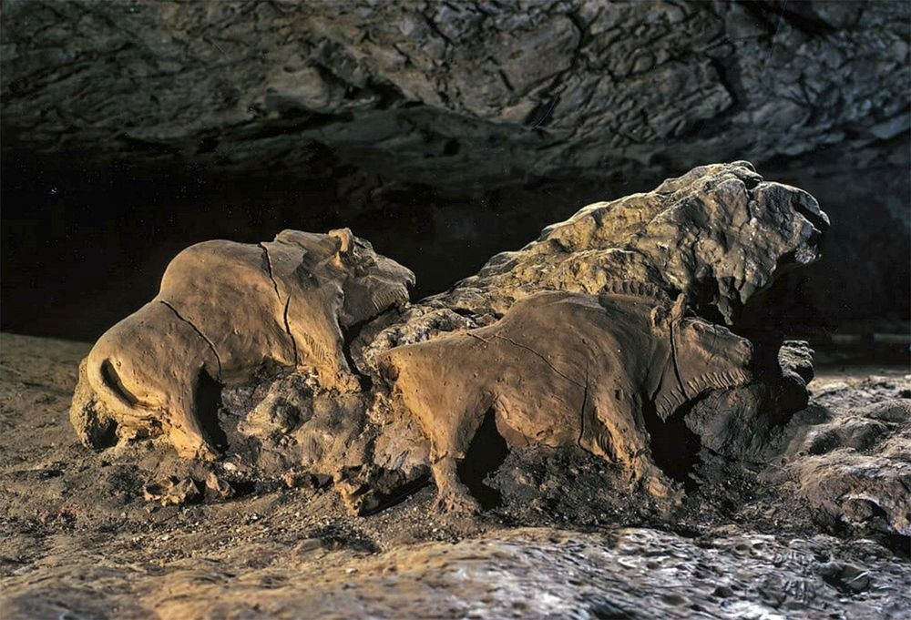
Aidan Leuck

The artwork above depicts two sculptures of bison in the Tuc d'Audoubert cave in France. The artpiece dates back approximately 15000 years ago and was created around 13000 BCE.

This sculpture is particularly important because it contains a few unique characteristics that sets it apart from other art found at the time. The color of the object is gray just like the stone that it was created on. There does not appear to be any paint that was used to give the fur any distinct colors. One unique characteristic is that this sculpture was created in very high relief, meaning the scultpure extends far out of its rock background. This gives the animals an almost three dimensional feel, particularly with the bison on the left. Based on the perspective viewed it can seem as if the bison is turned away from you. Both of these animals are created using 1-point perspective. The artist also used lines in order to represent the shaggy coat of the bison. Surprisingly something as simple as these lines does a good job portraying the fur.

The most interesting thing about these sculptures were how lifelike they look. It is unmistakable that they are bison. The amount of detail is really astonishing especially since the artist probably did not have access to a reference when sculpting this. I can’t draw a bison even with reference to look at. What makes it even more crazy is that this was sculpted out of rock, which isn’t the easiest material to work with and doesn’t leave a lot of room for error. The artist had to be precise and accurate when creating this the very first time. I think the theory about it being a ritual site makes the most sense. Perhaps they would gather here in order to summon bison so that they would be able to find enough food in order to survive.

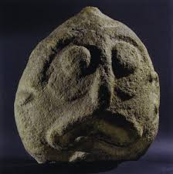

This sculpture was found beneath pre-historic houses in Lepenski Vir, Serbia and it dates to 6300-5500 BCE.

This sculpture is very distinctive and it appears to emulate a human head of sorts. The shape of the mouth is definitely strange and whether it is a person frowning or gasping in terror is up for interpretation. Many people describe the sculpture as a mix between a human and a fish based off of the shape of the mouth and large bulging eyes. The color of this sculpture is a grayish-brown, the same color as the rock it was created on. It is unclear whether the shape of the rock was sculpted to resemble a circle or if it was found as is. Due to the smoothness of the edge of the rock I would assume that the rock’s shape was original and the sculpture was just created by chipping away at the middle. The perspective appears to be one-perspective as we can also see the fact as it would appear from the front. I think the theory about it being involved with death and religious rituals makes the most since because it was found beneath people’s homes. Perhaps it represented the faces of ancestors that would watch over the house even in death.

The most interesting thing about this sculpture is to me is the eyes and mouth. It is not clear why the eyes are so large in proportion to the rest of the fact and it does not appear that they have any sort of pupil either. Furthermore, the mouth is really large and wide and appears to be frowning for whatever reason. If it is a hybrid between a fish and human it shows real creativity being able to combine a human with an animal. The other option is that it is just a really bad sculpture of a human and it just doesn’t represent a human very well.

Compare and Contrast: The most obvious difference between the two are that one appears to be representing a human, while the other appears to represent a bison. This may suggest that the first one may have been used as a way to summon animals, while the other one may have been used as a sort of burial. Furthermore, the first sculpture was done in high-relief while the other was done in relief because the head does not protrude from its background significantly. Although, the perspective’s are both one-perspective, I believe that the bison sculpture still has slightly different perspective because the sculpture can be viewed differently from certain angles because of the angle of the bison on the left. The medium of the two sculptures are the same, they were both made out of rock and the color of the sculptures appear to be quite similar.

